4.6.2 Triple Integrals in Spherical Coordinates Worksheet

- Change the following points from rectangular coordinates to spherical coordinates.

We note that
We know that .
We then need to find a value of that can satisfy each of the following:
We can deduce that .
Therefore when changed to cylindrical coordinates is .

We note that
We know that .
We then need to find a value of that can satisfy each of the following:
We can deduce that .
Therefore when changed to cylindrical coordinates is .

We note that
We know that .
We then need to find a value of that can satisfy each of the following:
We can deduce that .
Therefore when changed to cylindrical coordinates is .

We note that
We know that .
We then need to find a value of that can satisfy each of the following:
We can deduce that .
Therefore when changed to cylindrical coordinates is .

- True or False: Every point in can be uniquely represented in spherical coordinates.

FALSE. Since we have no restriction on , then we can simply replace with a coterminal value to arrive at the same point. Also, all points for which are the same point.

- Describe in words the surface who equation is given.
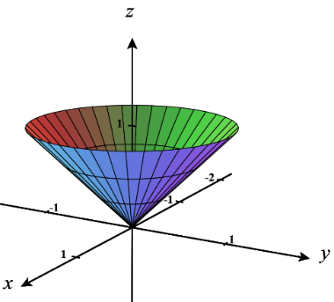

Here we note that and are free variables. So, our surface extends from the origin in all directions ( is free) and extends infinitely far from the origin in all directions ( is free). This creates the surface of a cone along the angle .

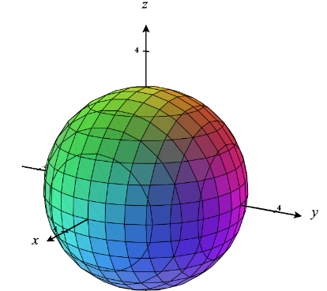
Here we note that and are free variables. So, our surface exists while facing any direction from the origin ( is free) and exists along every possible angle . Since is fixed at the value of 3, we have a surface that is a sphere of radius 3. This sphere has the equation .

- For each of the given integrals, label the box below the picture of the corresponding region of integration in spherical coordinates.
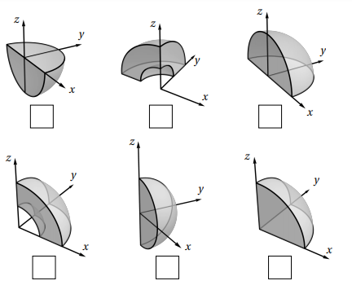

We see that the region of integration is given by:

We see that the region of integration is given by:

- For each of the given integrals, label the box below the picture of the corresponding region of integration in spherical coordinates.
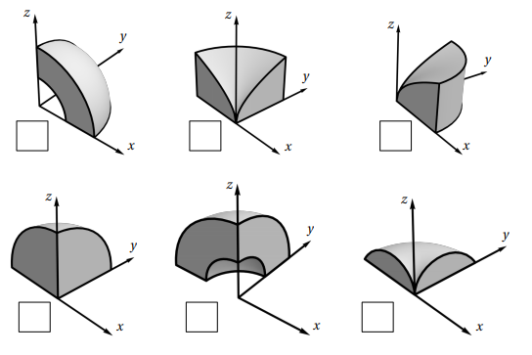

We see that the region of integration is given by:

We see that the region of integration is given by:

- The triple integral gives the volume of: (select which answer is correct)
- half a sphere of radius 2.
- One eighth of a sphere of radius 2.
- One quarter of a sphere of radius 2.

We see that the region of integration is given by:
Since no variable is bounded by any other, we know that we are dealing with a sphere.
Since we know that this will be a sphere of radius 2.
Based on the angles of we can conclude that this is 1/8 of sphere.

The correct option is (b).

- Sketch the solid whose volume is given by the integral and then evaluate the integral.
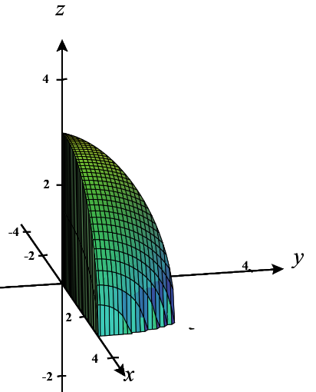

We see that our solid E is defined as .
Since the bounds are all constants we know that our region E is a portion of a sphere of radius 3. The bounds on imply that the sphere sits entirely above the xy-plane.

We see that our solid E is defined as .
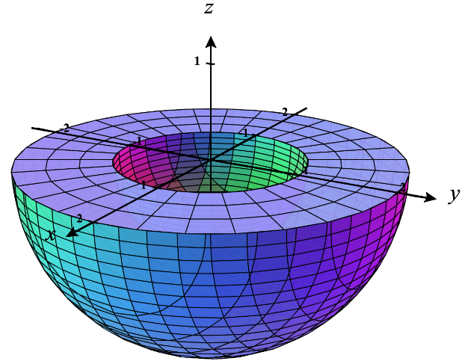
Since the bounds are all constants we know that our region E is a portion of a sphere of radius 2. The bounds on imply that we only want the portion of the sphere that also exists past the inner sphere of radius 1.

- Setup, but do not evaluate , where E is the solid hemisphere .

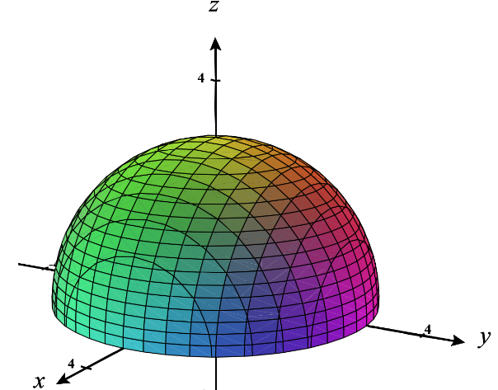
We first sketch a picture of our region E.
We can clearly establish the bounds on as .

We can also see that and .

- Evaluate , where E lies between the spheres and .
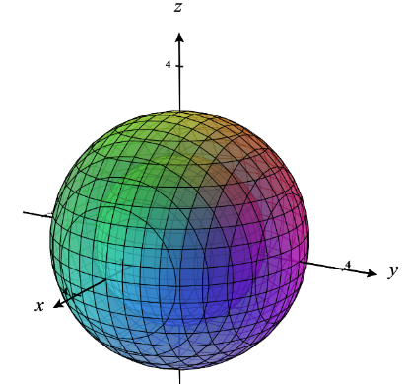
We first sketch a picture of our region E.
We can clearly establish the bounds on as .

We can also see that and .

- Evaluate , where E is the solid hemisphere the spheres .
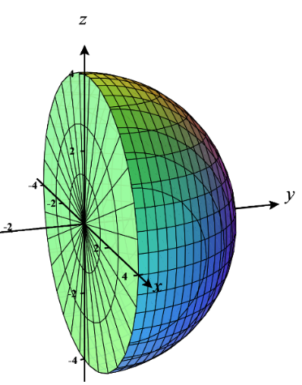
We first sketch a picture of our region E.
We can clearly establish the bounds on as .

We can also see that and .

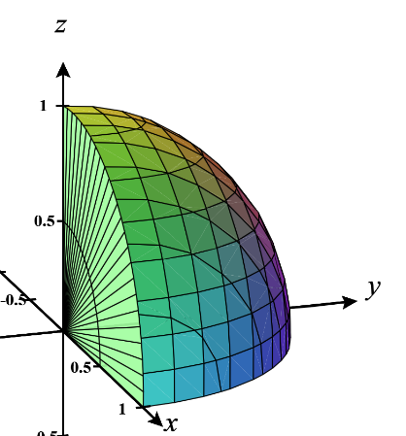
- Evaluate , where E is the portion of the unit ball that lies in the first octant.

We first sketch a picture of our region E.
We can clearly establish the bounds on as .

We can also see that and .

- Evaluate , where E lies between the spheres and and above the cone .
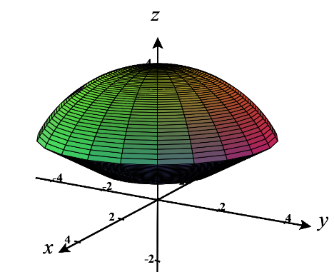
We first sketch a picture of our region E.
We can clearly establish the bounds on as .

We can also see that and .

- Find the volume of the part of the ball that lies between the cones and .

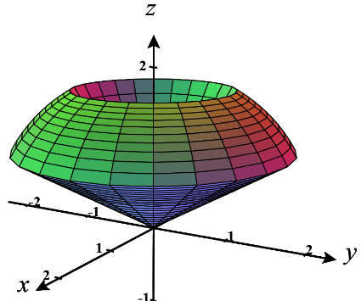
We first sketch a picture of our region E.
We can clearly establish the bounds on as .

We can also see that and .

- Convert each of the following integrals to cylindrical coordinates.

We see that the region of integration is given by:

From we see that
This tells us that we are working with some portion of a sphere of radius 3.
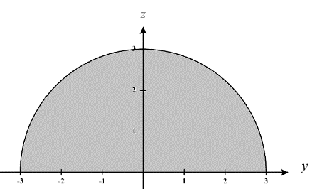
When we project E to the yz-plane we have a region which looks like the top half of a circle of radius 3.

Therefore, the solid we are integrating over is the top half of the sphere of radius 3.

Therefore, we express the original iterated integral as

We see that the region of integration is given by:
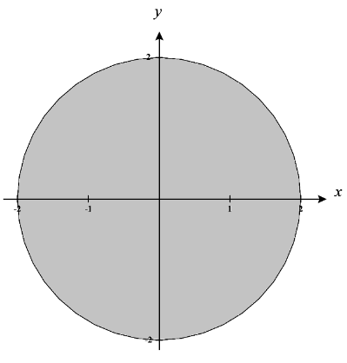
We can see that the projection into the xy-plane to get a region D, where
which looks like a full disk of radius 2. This immediately implies that .
We can see that z is bounded by a sphere of radius 2.
This immediately implies that .
Since we are dealing with the shape of a full sphere, we know that the bounds on should be .

Therefore, we express the original iterated integral as

We see that the region of integration is given by:
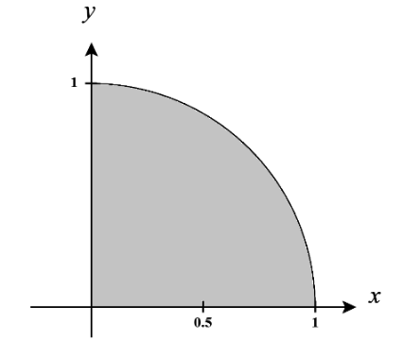
We can see that the projection into the xy-plane to get a region D, where
which looks like a quarter disk of radius 1 in quadrant I. This immediately implies that .
We can see that z is bounded between a cone and a sphere of radius .
This immediately implies that .
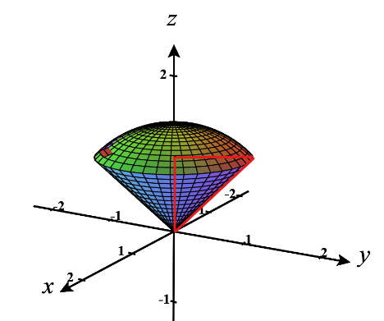
We need to determine the angle determined by the cone.
We sketch the red triangle and see that it has a hypotenuse of (the radius of the sphere) and a top leg length equal to the radius of the circle which is the intersection of the sphere and the cone.
We calculate this intersection to be
So, the leg length is 1. Therefore .
Therefore, we express the original iterated integral as

